Start Project Tasks
Business Problem statement:
A leading retail company wants to better understand its customers’ shopping behaviour in order to improve sales, customer satisfaction, and long-term loyalty. The management team has noticed changes in purchasing patterns across demographics, product categories, and sales channels. They are particularly interested in uncovering which factors, such as sales, product category and name, drive consumer decisions and repeat purchases.
You are tasked with analysing the company’s consumer behaviour dataset to answer the following overarching business question:
“Analyse the company’s sales data to identify revenue trends, top-performing products, regional performance, and profit margins. Build an interactive dashboard to present findings”.
Part 1: Data Understanding & Cleaning
1. Import the dataset into SQL
- First create a database named as project
- Next creating a table named as train
create table train(
Row_ID int auto_increment ,
Order_ID varchar(50),
Order_Date date,
Ship_Date date,
Ship_Mode varchar(50),
Customer_ID varchar(50),
Customer_Name varchar(100),
Segment varchar(50),
Country varchar(50),
City varchar(50),
State varchar(50),
Postal_Code varchar(50),
Region varchar(50),
Product_ID varchar(50),
Category varchar(50),
Sub_Category varchar(50),
Product_Name varchar(255),
Sales decimal(10,5)
);

- Next import excel csv file into the created sql table

LOAD DATA INFILE 'C:/ProgramData/MySQL/MySQL Server 9.3/Uploads/train.csv'
INTO TABLE train
FIELDS TERMINATED BY ','
ENCLOSED BY '"'
LINES TERMINATED BY '\n'
IGNORE 1 Rows

2. Check for missing values, duplicate records, and inconsistent data types
- Finding Missing Values
SELECT
SUM(CASE WHEN row_id IS NULL THEN 1 ELSE 0 END) AS col1_nulls,
SUM(CASE WHEN Order_ID IS NULL THEN 1 ELSE 0 END) AS col2_nulls,
SUM(CASE WHEN Order_Date IS NULL THEN 1 ELSE 0 END) AS col3_nulls,
SUM(CASE WHEN Ship_date IS NULL THEN 1 ELSE 0 END) AS col4_nulls,
SUM(CASE WHEN ship_mode IS NULL THEN 1 ELSE 0 END) AS col5_nulls,
SUM(CASE WHEN customer_ID IS NULL THEN 1 ELSE 0 END) AS col6_nulls,
SUM(CASE WHEN customer_name IS NULL THEN 1 ELSE 0 END) AS col7_nulls,
SUM(CASE WHEN segment IS NULL THEN 1 ELSE 0 END) AS col8_nulls,
SUM(CASE WHEN country IS NULL THEN 1 ELSE 0 END) AS col9_nulls,
SUM(CASE WHEN city IS NULL THEN 1 ELSE 0 END) AS col10_nulls,
SUM(CASE WHEN state IS NULL THEN 1 ELSE 0 END) AS col11_nulls,
SUM(CASE WHEN postal_code IS NULL THEN 1 ELSE 0 END) AS col12_nulls,
SUM(CASE WHEN category IS NULL THEN 1 ELSE 0 END) AS col13_nulls,
SUM(CASE WHEN sub_category IS NULL THEN 1 ELSE 0 END) AS col4_nulls,
SUM(CASE WHEN product_name IS NULL THEN 1 ELSE 0 END) AS col15_nulls,
SUM(CASE WHEN sales IS NULL THEN 1 ELSE 0 END) AS col16_nulls
FROM train;

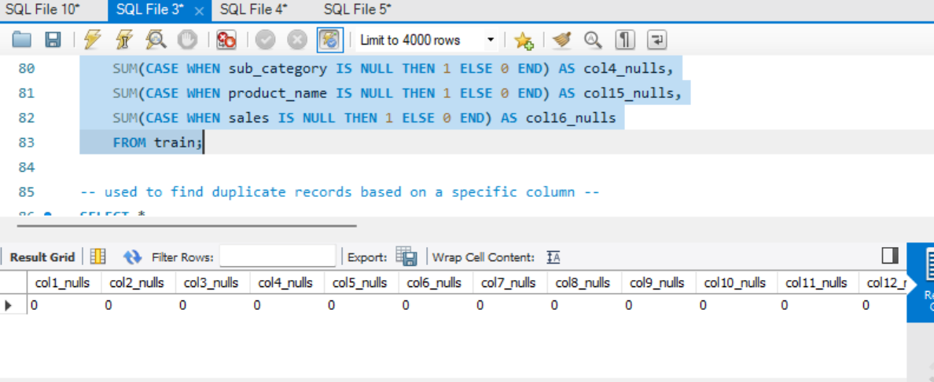

- Finding Duplicate Records
SELECT *
FROM (
SELECT *,
ROW_NUMBER() OVER (
PARTITION BY Row_ID,Order_ID,Order_Date,Ship_Date,Ship_Mode,Customer_ID,Customer_Name,Segment,Country,City,State,
Postal_Code,Region,Product_ID,Category,Sub_Category,Product_Name,Sales
ORDER BY row_id
) AS rn
FROM train
) t
WHERE rn > 1;

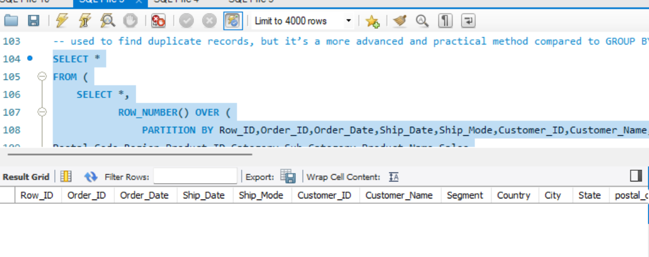

- Finding inconsistent data types

DESCRIBE train;

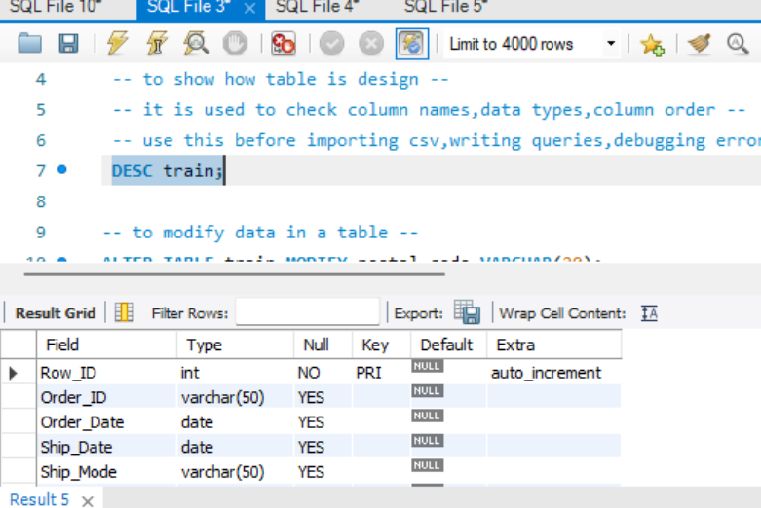

3. Clean and transform the data for analysis

- Remove Duplicate Records

DELETE FROM train
WHERE row_id IN (
SELECT row_id
FROM (
SELECT row_id,
ROW_NUMBER() OVER (
PARTITION BY Order_ID, Product_ID
ORDER BY row_id
) AS rn
FROM train
) t
WHERE rn > 1
);

Part 2: KPI Analysis

Calculate the following KPIs:

- Total Sales

SELECT SUM(sales) AS total_sales
FROM train;

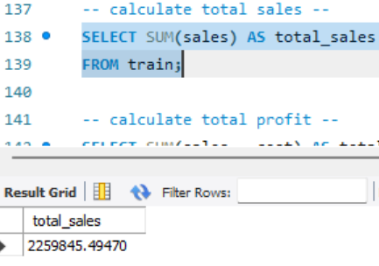

- Total Profit

There is no profit column in the given file so we take estimated profit.

SELECT SUM(sales * 0.20) AS estimated_profit
FROM train;

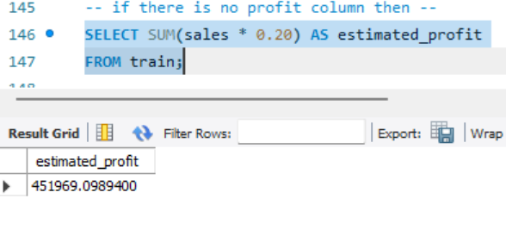

- Profit Margin %

SELECT (SUM(sales * 0.20) / SUM(sales)) * 100 AS profit_margin_percentage
FROM train;

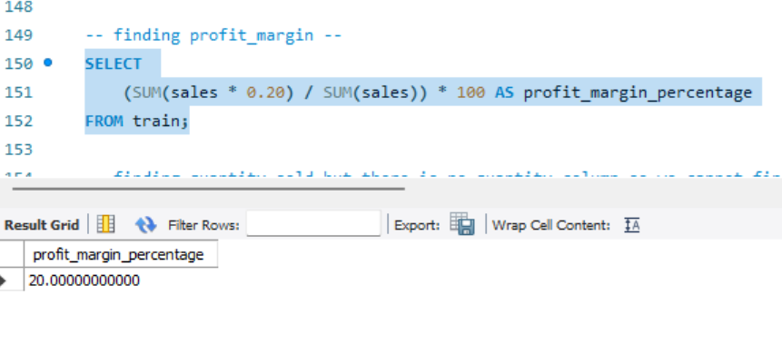

- Total Quantity Sold

There is no quantity column so we cannot calculate total quantity sold accurately.

- Average Order Value

SELECT
SUM(sales) / COUNT(DISTINCT order_id) AS average_order_value
FROM train;

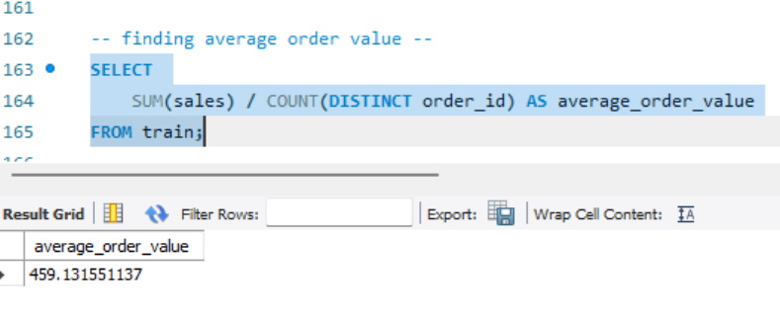

Part 3: Business Analysis

- Which are the Top 10 products by sales?

SELECT
product_name,
SUM(sales) AS total_sales
FROM train
GROUP BY product_name
ORDER BY total_sales DESC
LIMIT 10;

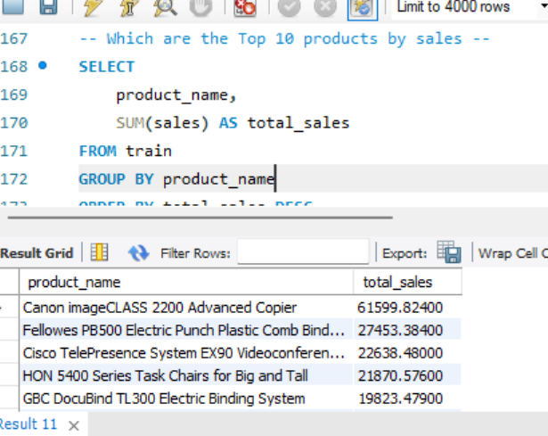

- Which products are making losses?
SELECT
product_name,
SUM(sales) AS total_sales
FROM train
GROUP BY product_name
ORDER BY total_sales ASC
LIMIT 10;

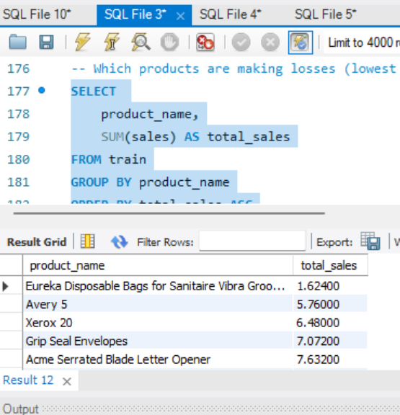

- Which region/state/city has the highest sales?

- Region with highest sales
SELECT
region,
SUM(sales) AS total_sales
FROM train
GROUP BY region
ORDER BY total_sales DESC
LIMIT 1;

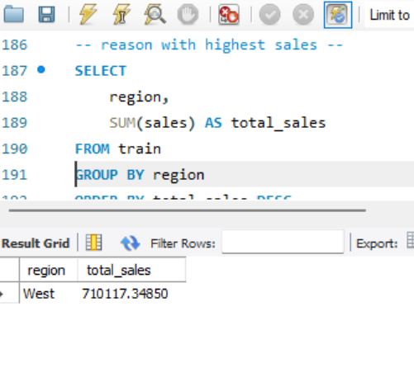

- State with highest sales

SELECT
state,
SUM(sales) AS total_sales
FROM train
GROUP BY state
ORDER BY total_sales DESC
LIMIT 1;

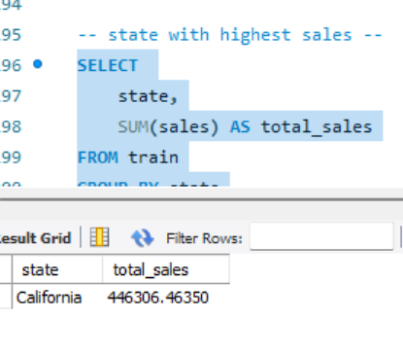

- City with highest Sales

SELECT
city,
SUM(sales) AS total_sales
FROM train
GROUP BY city
ORDER BY total_sales DESC
LIMIT 1;

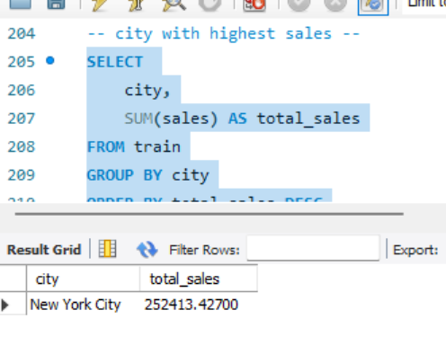

- Which region/state/city has the lowest sales?

- Region with lowest sales

SELECT
region,
SUM(sales) AS total_sales
FROM train
GROUP BY region
ORDER BY total_sales ASC
LIMIT 1;

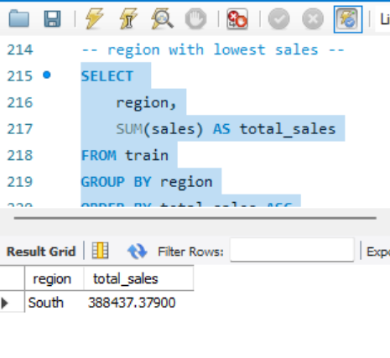

- State with lowest sales

SELECT
state,
SUM(sales) AS total_sales
FROM train
GROUP BY state
ORDER BY total_sales ASC
LIMIT 1;

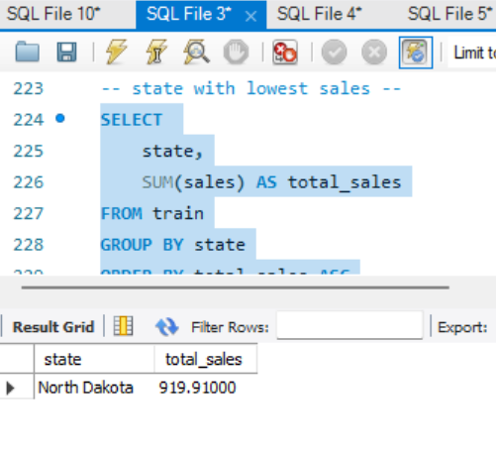

- City with lowest sales

SELECT
city,
SUM(sales) AS total_sales
FROM train
GROUP BY city
ORDER BY total_sales ASC
LIMIT 1;

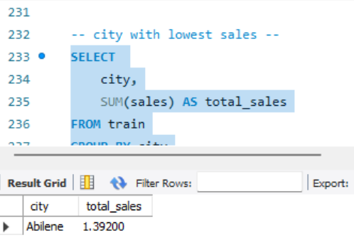

- Which category/sub-category contributes the most profit?

- Category with highest sales

SELECT
category,
SUM(sales) AS total_sales
FROM train
GROUP BY category
ORDER BY total_sales DESC
LIMIT 1;

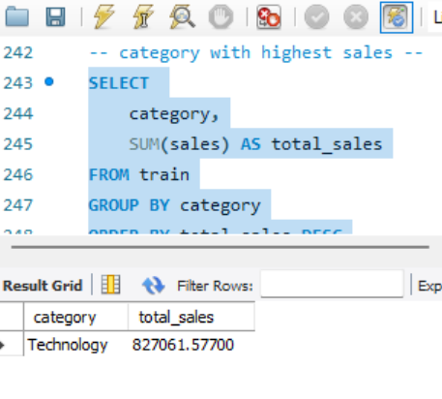

- Sub-category with highest sales

SELECT
sub_category,
SUM(sales) AS total_sales
FROM train
GROUP BY sub_category
ORDER BY total_sales DESC
LIMIT 1;

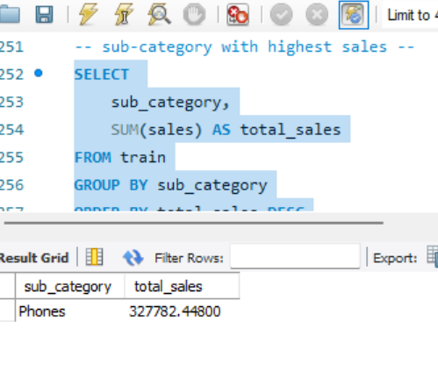

- Which months have the highest and lowest sales?

- Monthly Sales Analysis

SELECT
MONTHNAME(order_date) AS month_name,
SUM(sales) AS total_sales
FROM train
GROUP BY MONTH(order_date), MONTHNAME(order_date)
ORDER BY total_sales DESC;

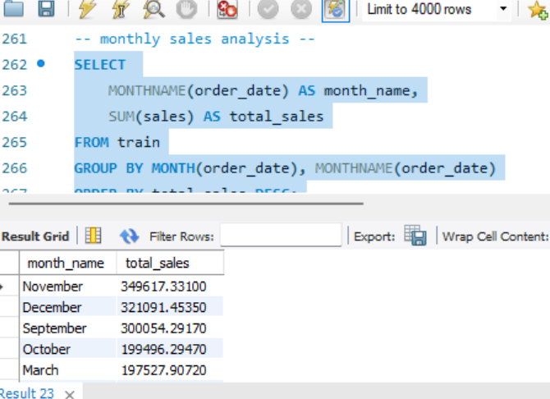

- Month with highest Sales

SELECT
MONTHNAME(order_date) AS month_name,
SUM(sales) AS total_sales
FROM train
GROUP BY MONTH(order_date), MONTHNAME(order_date)
ORDER BY total_sales DESC
LIMIT 1;

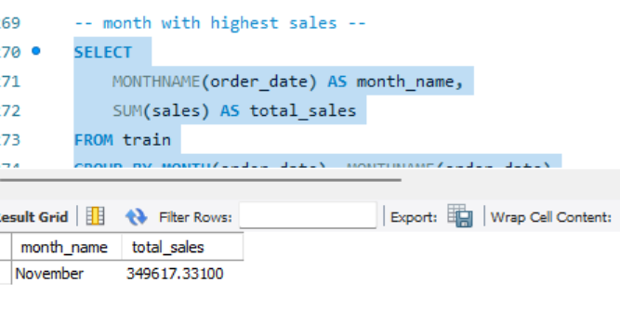

- Month with lowest Sales

SELECT
MONTHNAME(order_date) AS month_name,
SUM(sales) AS total_sales
FROM train
GROUP BY MONTH(order_date), MONTHNAME(order_date)
ORDER BY total_sales ASC
LIMIT 1;

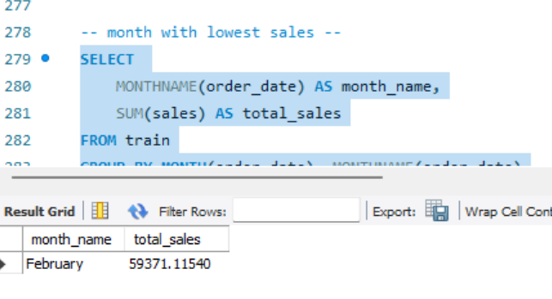

- Identify seasonal trends in sales.

- Monthly Sales Trend

SELECT
MONTH(order_date) AS month_number,
MONTHNAME(order_date) AS month_name,
SUM(sales) AS total_sales
FROM train
GROUP BY MONTH(order_date), MONTHNAME(order_date)
ORDER BY month_number;

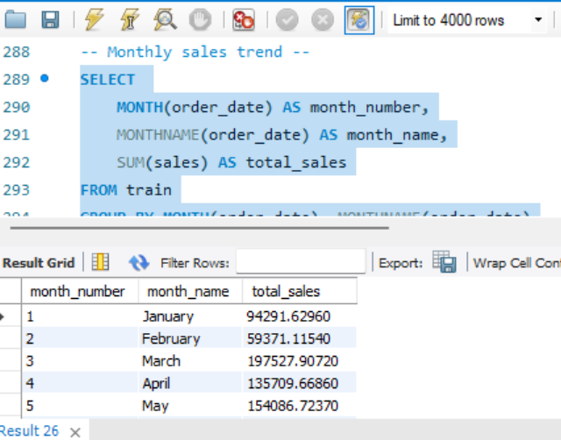

- Quarterly Sales Trend
SELECT
QUARTER(order_date) AS quarter,
SUM(sales) AS total_sales
FROM train
GROUP BY QUARTER(order_date)
ORDER BY quarter;

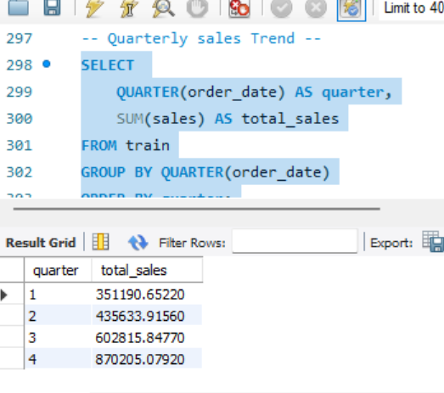
- Yearly Sales Trend
SELECT
YEAR(order_date) AS year,
SUM(sales) AS total_sales
FROM train
GROUP BY YEAR(order_date)
ORDER BY year;

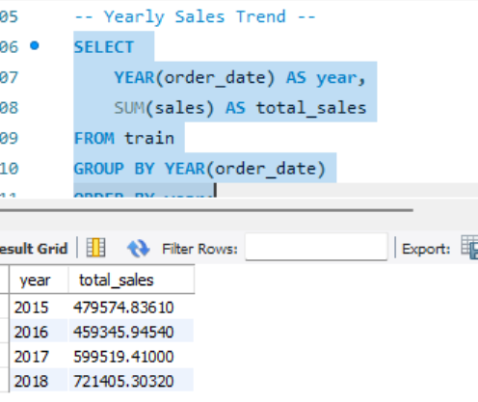

- Month – over – Month – Trend

SELECT
YEAR(order_date) AS year,
MONTHNAME(order_date) AS month,
SUM(sales) AS total_sales
FROM train
GROUP BY YEAR(order_date), MONTH(order_date), MONTHNAME(order_date)
ORDER BY YEAR(order_date), MONTH(order_date);

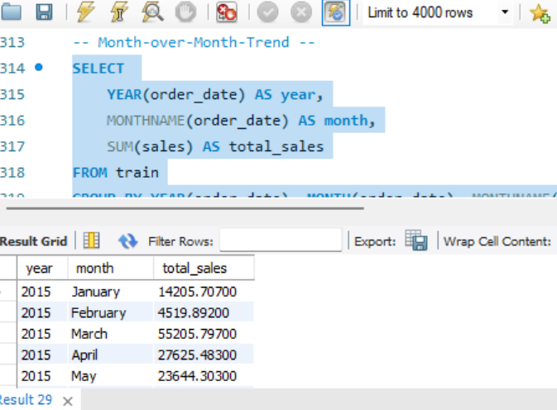

Part 4: Dashboard Creation

Build an interactive dashboard containing:

- Sales Trend Chart
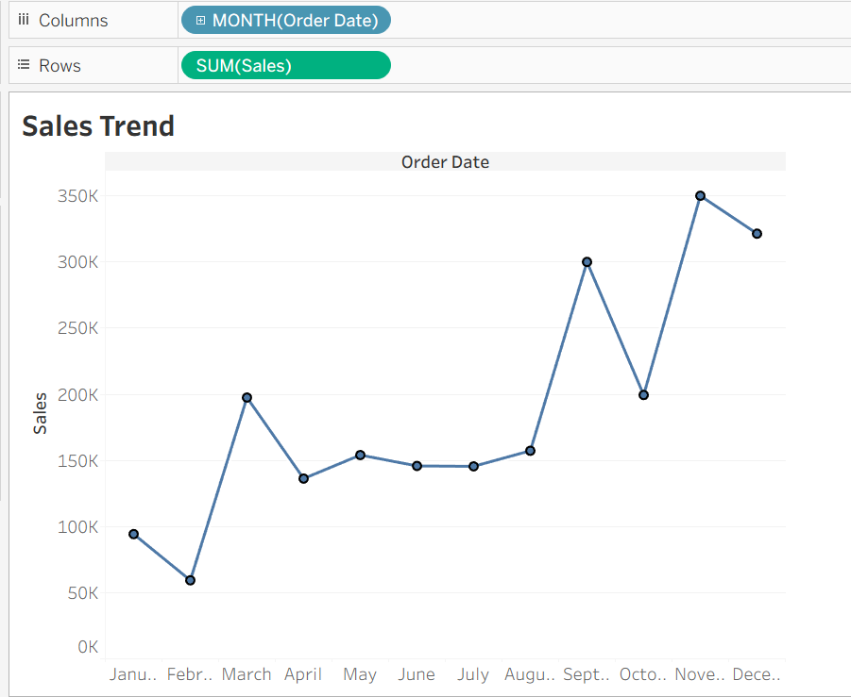

- Region-wise sales chart
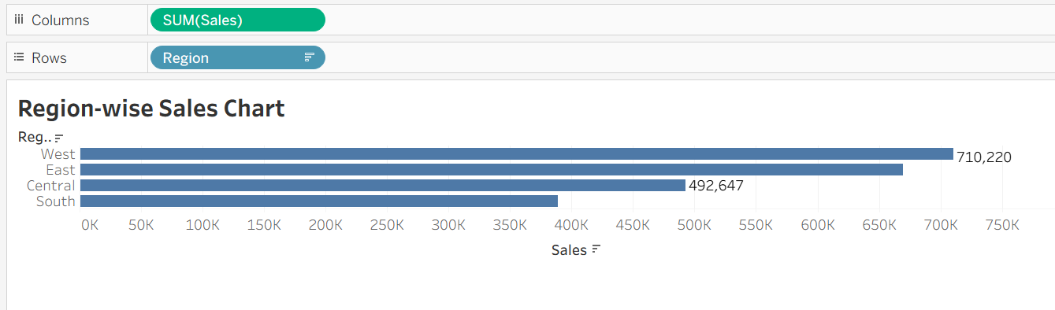

- Top 10 product

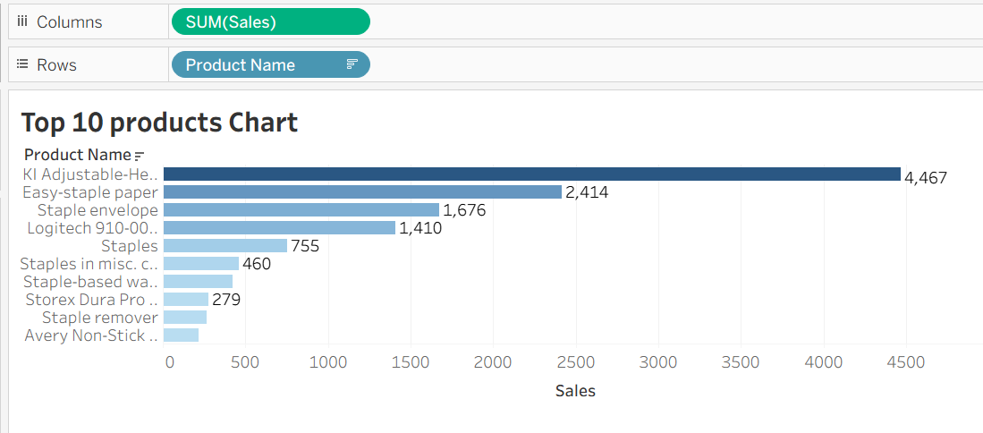

- Category wise profits chart

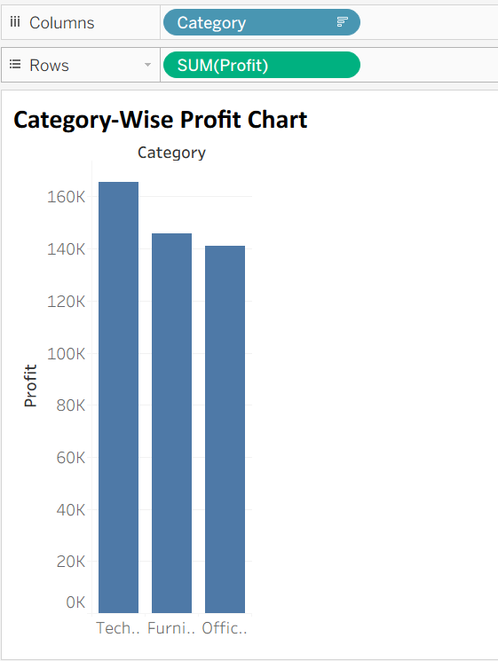

- Filters (Date, region, category)

